Nearly Half of U.S. Lives in Household Receiving Government Benefit
By Sara Murray

October 5, 2011, 2:31 PM ET

Families were more dependent on government programs than ever last year.

Nearly half, 48.5%, of the population lived in a household that received some type of government benefit in the first quarter of 2010, according to Census data. Those numbers have risen since the middle of the recession when 44.4% lived households receiving benefits in the third quarter of 2008.

The share of people relying on government benefits has reached a historic high, in large part from the deep recession and meager recovery, but also because of the expansion of government programs over the years. (See a timeline on the history of government benefits programs here.)
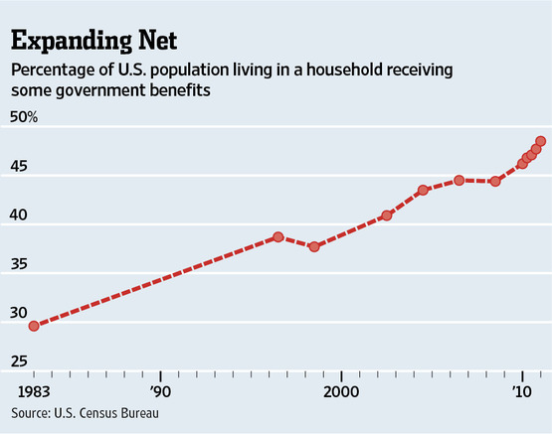

Means-tested programs, designed to help the needy, accounted for the largest share of recipients last year. Some 34.2% of Americans lived in a household that received benefits such as food stamps, subsidized housing, cash welfare or Medicaid (the federal-state health care program for the poor).

Another 14.5% lived in homes where someone was on Medicare (the health care program for the elderly). Nearly 16% lived in households receiving Social Security.

High unemployment and increased reliance on government programs has also shrunk the nation’s share of taxpayers. Some 46.4% of households will pay no federal income tax this year, according to the nonpartisan Tax Policy Center. That’s up from 39.9% in 2007, the year the recession began.

Just 18.1% of households pay neither payroll nor federal income taxes and they are predominantly the nation’s elderly and poorest families.

The tandem rise in government-benefits recipients and fall in taxpayers has been cause for alarm among some policymakers and presidential hopefuls.

Benefits programs have come under closer scrutiny as policymakers attempt to tame the federal government’s budget deficit. President Barack Obama and members of Congress considered changes to Social Security and Medicare as part of a grand bargain (that ultimately fell apart) to raise the debt ceiling earlier this year. Cuts to such programs could emerge again from the so-called “super committee,” tasked with releasing a plan to rein in the deficit.

Republican presidential hopefuls, meanwhile, have latched onto the fact that nearly half of households pay no federal income tax, saying too many Americans aren’t paying their fair share.

UPDATE: Nearly half of the population lives in a household that has at least one member who receives some kind of government benefit. An earlier headline incorrectly suggested that half of American households receive some government benefit. Due to differences in household size that isn’t the case.

